# Week 2 – Soap

## Wsdl

The client first makes a request to the ?wsdl endpoint. This endpoint returns the description of the interface in XML. In it is defined which methods (in wsdl described as operation) are defined.

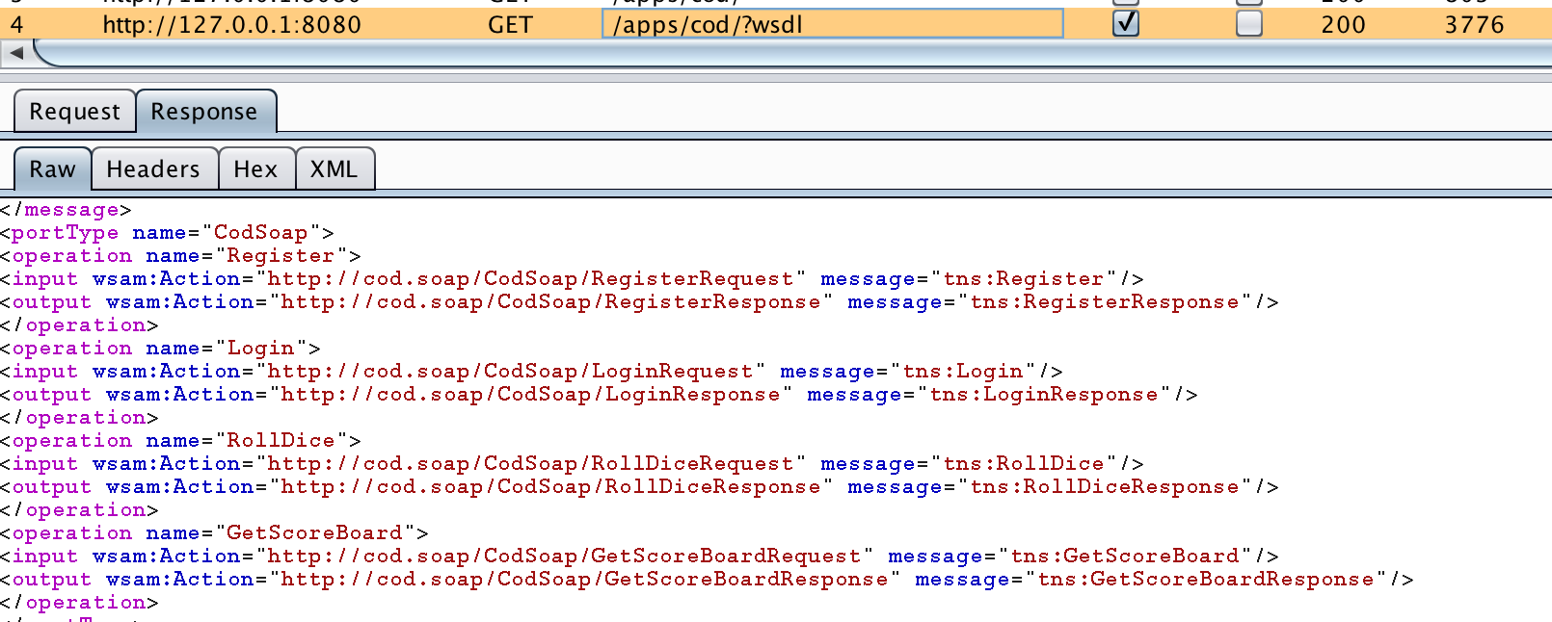

I expected inside the wsdl file also to have all the Classes to be defined too. Couldn’t find it hence, I ran the wsimport tool on the proxy. I found out that it used another endpoint which ends with ?xsd=1. In this file are all the Classes described from which the wsimport tool generates the Java files.

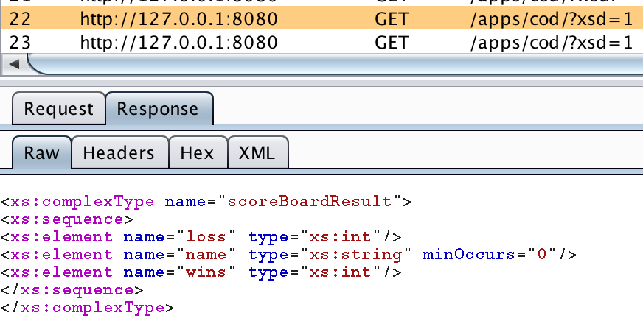

## SOAP

In the figure below is the XML file send by my client to the server. Inside the XML file is the method name defined and the arguments used.

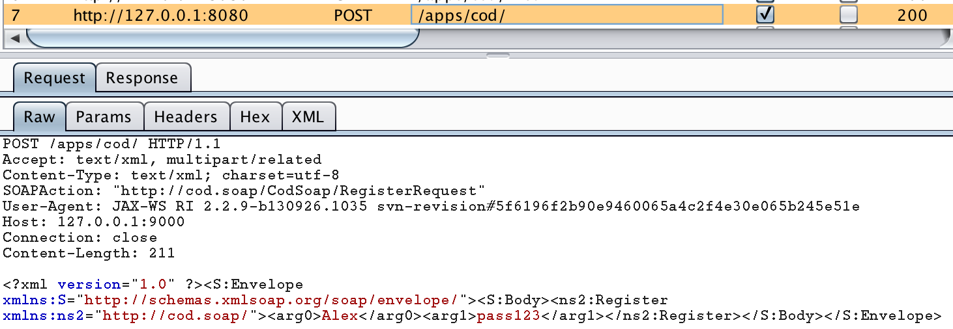

I like the plugin from Chrome called Wizdler, which I used with WCF before. I like it because you can create your own SOAP message. If I remember well in WCF the parameters were not called arg0 but the real parameter name, which made it even easier to use.

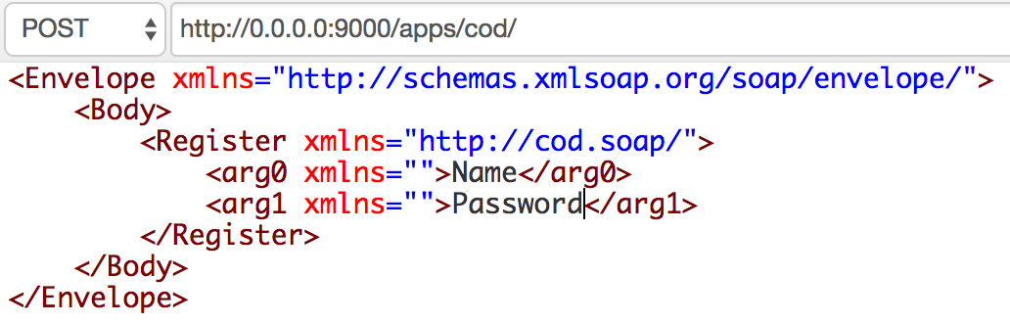

I try to make the service response similar structure as many JSON API’s. It has two attributes: success and message:

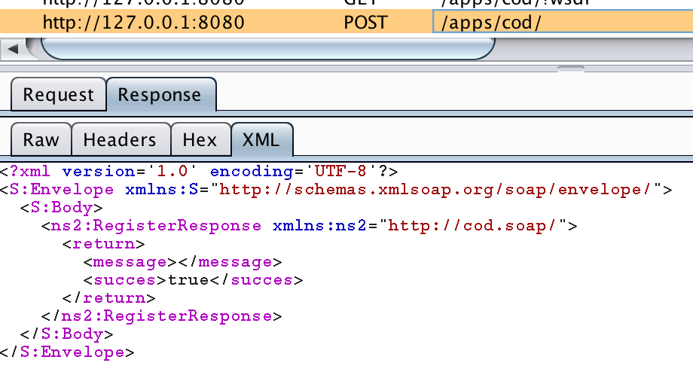

When the action was not successful then the message will be filled:

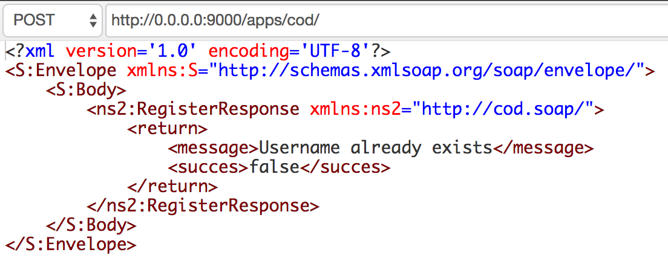

SOAP also sends exceptions (in SOAP fault) to the client. Interestingly because it uses the HTTP protocol it will also send the 500-status code.

